Table of Contents
Lab No: 01 1
Lab No: 02 3
Lab No: 03 7
Lab No: 04 9
Lab No: 05 11
Lab No: 06 14
Lab No: 07 16
Lab No: 08 18
Lab No: 09 20
Lab No: 10 22
Lab No: 11 24
Lab No: 12 26
Lab No: 13 28
Lab No: 14 30

Lab No: 01 Caesar Cipher
1. Title of Experiment
Program to encrypt and decrypt a message using the Caesar cipher.
2. Objective
To implement a program that encrypts and decrypts a message using the Caesar cipher substitution technique.
3. Required Software/Hardware
- A computer running Windows / Linux / macOS
- Visual Studio Code (VS Code) IDE
- Python 3 installed and added to PATH
- An integrated terminal (built into VS Code) to run the program and view its output
4. Theory
The Caesar cipher is a simple encryption technique that was used by Julius Caesar to send secret messages to his allies. It works by shifting the letters in the plaintext message by a certain number of positions, known as the "shift" or "key". It is one of the earliest and simplest methods of encryption.
It is a type of substitution cipher: each letter of the text is replaced by a letter a fixed number of positions down the alphabet. For example, with a shift of 1, A becomes B, B becomes C, and so on. It is easy to implement but is not secure against modern cryptanalysis and lacks confidentiality, integrity, and authenticity for real-world use.
5. Procedure/Algorithm
- Take the plaintext message and the shift value (key) as input.
- For encryption, traverse each character of the message.
- If the character is an uppercase letter, shift it within A-Z using (ord(ch) + shift - 65) % 26 + 65.
- Otherwise, shift it within a-z using (ord(ch) + shift - 97) % 26 + 97.
- Concatenate all shifted characters to form the ciphertext.
- For decryption, repeat the same idea but subtract the shift instead of adding it, leaving non-alphabetic characters unchanged.
- Display the original text, the shift value, and the resulting cipher/decrypted text.
6. Implementation/Steps
a. Encryption
def encrypt(text, s):
result = ""
# traverse text
for i in range(len(text)):
ch = text[i]
# Encrypt Uppercase letters
if ch.isupper():
result += chr((ord(ch) + s - 65) % 26 + 65)
# Encrypt everything else as lowercase
else:
result += chr((ord(ch) + s - 97) % 26 + 97)
return result

# Driver Code
text = "Hello Paaji"
s = 4
print("Text :", text)
print("Shift:", s)
print("Cipher:", encrypt(text, s))
b. Decryption
def decrypt(text, s):
result = ""

# traverse text
for i in range(len(text)):
ch = text[i]
# Decrypt Uppercase letters
if ch.isupper():
result += chr((ord(ch) - s - 65 + 26) % 26 + 65)
# Decrypt Lowercase letters
elif ch.islower():
result += chr((ord(ch) - s - 97 + 26) % 26 + 97)
# Non-alphabetic characters
else:
result += ch

return result

# Driver Code
cipher_text = " LippsrAsvph"
s = 4
print("Cipher:", cipher_text)
print("Shift:", s)
print("Decrypted Text:", decrypt(cipher_text, s))
7. Output

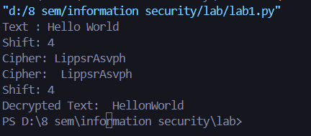

8. Result
The program successfully encrypted "Hello World" into "LippsrAsvph" using a shift of 4, and correctly decrypted the ciphertext back, confirming that the Caesar cipher encryption and decryption logic works as expected.

Lab No: 02 Playfair Cipher
1. Title of Experiment
Program to encrypt and decrypt a user input message using the Playfair cipher and display the key matrix.
2. Objective
To implement a program that builds a Playfair 5x5 key matrix from a keyword and uses it to encrypt and decrypt a user input message.
3. Required Software/Hardware
- A computer running Windows / Linux / macOS
- Visual Studio Code (VS Code) IDE
- Python 3 installed and added to PATH
- An integrated terminal (built into VS Code) to run the program and view its output
4. Theory
Playfair cipher is an encryption algorithm that encrypts a digraph (a pair of two letters) instead of a single letter, unlike a simple substitution cipher.
It initially creates a key-table of a 5x5 matrix containing alphabets that act as the key for encryption. No alphabet is repeated in the matrix. Since there are 26 letters but only 25 cells, one letter is omitted (usually J); if the plaintext contains J, it is treated the same as I.
5. Procedure/Algorithm
- Take a keyword and a message as input.
- Generate a 5x5 Playfair matrix by placing the unique keyword letters first (treating I/J as the same letter), followed by the remaining alphabet letters.
- Preprocess the message: convert to uppercase, replace J with I, remove non-letters, and split it into digraphs (letter pairs), inserting X between repeated letters or as padding for an odd-length message.
- For each digraph, locate both letters' row and column in the matrix.
- Apply the Playfair rule: same row -> shift both letters right; same column -> shift both down; otherwise -> swap using the rectangle formed by the two letters.
- To decrypt, apply the reverse rule (shift left/up instead of right/down).
- Display the generated matrix and the resulting encrypted/decrypted message.
6. Implementation/Steps
def generate_playfair_matrix(keyword):
alphabet = "ABCDEFGHIKLMNOPQRSTUVWXYZ"
matrix = []
used_chars = set()
keyword = keyword.upper()
for ch in keyword:
if ch not in used_chars and ch in alphabet:
matrix.append(ch)
used_chars.add(ch)
for ch in alphabet:
if ch not in used_chars:
matrix.append(ch)
used_chars.add(ch)
# Reshape the list into a 5x5 matrix
return [matrix[i * 5:(i + 1) * 5] for i in range(5)]

def preprocess_text(text):
text = text.upper().replace('J', 'I')
text = ''.join(ch for ch in text if ch.isalpha())
digraphs = []
i = 0
while i < len(text):
digraph = text[i]
if i + 1 < len(text) and text[i] != text[i + 1]:
digraph += text[i + 1]
i += 2
else:
digraph += 'X'
i += 1
digraphs.append(digraph)
return digraphs

def find_position(matrix, char):
for row in range(5):
for col in range(5):
if matrix[row][col] == char:
return row, col
return None

def encrypt_digraph(matrix, digraph):
row1, col1 = find_position(matrix, digraph[0])
row2, col2 = find_position(matrix, digraph[1])

if row1 == row2:
return matrix[row1][(col1 + 1) % 5] + matrix[row2][(col2 + 1) % 5]
elif col1 == col2:
return matrix[(row1 + 1) % 5][col1] + matrix[(row2 + 1) % 5][col2]
else:
return matrix[row1][col2] + matrix[row2][col1]

def decrypt_digraph(matrix, digraph):
row1, col1 = find_position(matrix, digraph[0])
row2, col2 = find_position(matrix, digraph[1])

if row1 == row2:
return matrix[row1][(col1 - 1) % 5] + matrix[row2][(col2 - 1) % 5]
elif col1 == col2:
return matrix[(row1 - 1) % 5][col1] + matrix[(row2 - 1) % 5][col2]
else:
return matrix[row1][col2] + matrix[row2][col1]

def encrypt_message(keyword, message):
matrix = generate_playfair_matrix(keyword)
digraphs = preprocess_text(message)
encrypted_message = ''.join(encrypt_digraph(matrix, d) for d in digraphs)
return matrix, encrypted_message

def decrypt_message(keyword, encrypted_message):
matrix = generate_playfair_matrix(keyword)
digraphs = preprocess_text(encrypted_message)
decrypted_message = ''.join(decrypt_digraph(matrix, d) for d in digraphs)
return decrypted_message

def display_matrix(matrix):
for row in matrix:
print(' '.join(row))

# Example usage
keyword = "keyword"
message = "hello world"
matrix, encrypted_message = encrypt_message(keyword, message)
print("Playfair Matrix:")
display_matrix(matrix)

print("\nEncrypted Message:", encrypted_message)

decrypted_message = decrypt_message(keyword, encrypted_message)
print("Decrypted Message:", decrypted_message)
7. Output/Screenshot

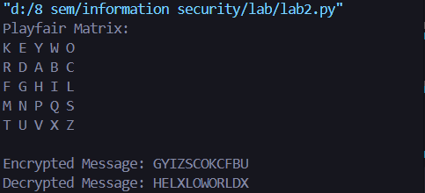
8. Result
The program generated the Playfair matrix from the keyword "keyword", encrypted "hello world" into ciphertext, and correctly decrypted it back, verifying that the Playfair cipher implementation works as expected.

Lab No: 03 Rail Fence Cipher
1. Title of Experiment
Program to encrypt and decrypt a user input message using the Rail Fence cipher.
2. Objective
To implement a program that encrypts and decrypts a user input message using the Rail Fence transposition cipher.
3. Required Software/Hardware
- A computer running Windows / Linux / macOS
- Visual Studio Code (VS Code) IDE
- Python 3 installed and added to PATH
- An integrated terminal (built into VS Code) to run the program and view its output
4. Theory
The Rail Fence Cipher is a type of transposition cipher. It rearranges the characters of the plaintext to encrypt the message. The method involves writing the plaintext in a zig-zag pattern along a specified number of "rails" (rows), then reading off each row sequentially to produce the ciphertext. To decrypt, the process is reversed.
5. Procedure/Algorithm
- Take the plaintext message and the number of rails as input.
- Write the message characters in a zig-zag pattern across the given number of rails, moving down then up repeatedly.
- Read off the characters row by row to form the ciphertext.
- To decrypt, first calculate how many characters belong to each rail by simulating the same zig-zag movement.
- Fill the rails with the ciphertext characters according to those calculated lengths.
- Read the characters back following the original zig-zag order to reconstruct the plaintext.
6. Implementation/Steps
def encrypt_rail_fence(message, num_rails):
rails = [[] for _ in range(num_rails)]
rail = 0
direction = 1

for ch in message:
rails[rail].append(ch)
rail += direction

if rail == 0 or rail == num_rails - 1:
direction *= -1

return ''.join(''.join(r) for r in rails)

def decrypt_rail_fence(cipher_text, num_rails):
rails = [[] for _ in range(num_rails)]
rail_length = [0] * num_rails
rail = 0
direction = 1

for _ in cipher_text:
rail_length[rail] += 1
rail += direction

if rail == 0 or rail == num_rails - 1:
direction *= -1

index = 0
for i in range(num_rails):
for _ in range(rail_length[i]):
rails[i].append(cipher_text[index])
index += 1

rail = 0
direction = 1
decrypted_text = ""

for _ in cipher_text:
decrypted_text += rails[rail].pop(0)
rail += direction

if rail == 0 or rail == num_rails - 1:
direction *= -1

return decrypted_text

# Example usage
num_rails = int(input("Enter the number of rails: "))
message = input("Enter the message: ")

encrypted_message = encrypt_rail_fence(message, num_rails)
print("Encrypted Message:", encrypted_message)

decrypted_message = decrypt_rail_fence(encrypted_message, num_rails)
print("Decrypted Message:", decrypted_message)
7. Output/Screenshot
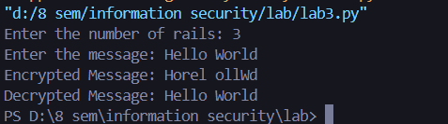

8. Result
The program correctly encrypted and decrypted a sample message using the Rail Fence cipher for a chosen number of rails, confirming that the zig-zag transposition and its reverse process both work correctly.

Lab No: 04 AES State Array
1. Title of Experiment
Program to convert a user input message into a 4x4 state array as used in AES.
2. Objective
To implement a program that organizes a 16-byte user input message into the 4x4 'state array' format used internally by AES.
3. Required Software/Hardware
- A computer running Windows / Linux / macOS
- Visual Studio Code (VS Code) IDE
- Python 3 installed and added to PATH
- An integrated terminal (built into VS Code) to run the program and view its output
4. Theory
In the Advanced Encryption Standard (AES), the plaintext input is organised into a 4x4 grid called the "state array." Each cell of this array holds a byte of data. The state array undergoes several transformations during the encryption and decryption processes. AES works with data in blocks of 16 bytes, represented as this 4x4 grid, which undergoes various transformations during encryption and decryption.
5. Procedure/Algorithm
- Take a user input message of up to 16 characters.
- Pad the message with null bytes if it is shorter than 16 bytes.
- Map each byte of the message into a 4x4 grid, filling it column by column as per the AES state array convention.
- Display the resulting state array in hexadecimal format.
6. Implementation/Steps
def create_state_array(user_input):
state = [[0] * 4 for _ in range(4)]
user_input = user_input.ljust(16, '\0')[:16] # Pad/trim input to 16 bytes
for i in range(16):
state[i % 4][i // 4] = ord(user_input[i])
return state

def print_state_array(state):
for row in range(4):
for col in range(4):
print(f"{state[row][col]:02X}", end=" ")
print()

# Example usage
user_input = input("Enter a message (up to 16 characters): ")

state_array = create_state_array(user_input)
print("4x4 State Array:")
print_state_array(state_array)
7. Output/Screenshot

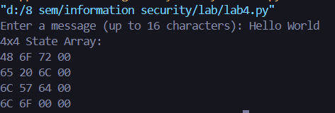
8. Result
The program successfully converted the input message into a 16-byte, 4x4 AES state array and displayed it in hexadecimal form, matching the standard AES state array layout.

Lab No: 05 DES Key Generation
1. Title of Experiment
Program to simulate key generation of the DES algorithm.
2. Objective
To implement a program that simulates the DES key schedule, generating all 16 round subkeys from a 64-bit input key.
3. Required Software/Hardware
- A computer running Windows / Linux / macOS
- Visual Studio Code (VS Code) IDE
- Python 3 installed and added to PATH
- An integrated terminal (built into VS Code) to run the program and view its output
4. Theory
The Data Encryption Standard (DES) is a symmetric-key algorithm for the encryption of digital data. DES operates with a 56-bit key, actually derived from an initial 64-bit key by discarding every 8th bit (used for parity). The key generation process in DES involves creating 16 subkeys, each of 48 bits, one used in each of the 16 rounds of the encryption process.
5. Procedure/Algorithm
- Take a 64-bit binary key as input.
- Apply Permutation Choice 1 (PC-1) to reduce the 64-bit key to 56 bits.
- Split the resulting 56 bits into two 28-bit halves (left and right).
- For each of the 16 rounds, left-rotate both halves by the number of positions defined in the rotation schedule.
- Combine the rotated halves and apply Permutation Choice 2 (PC-2) to produce a 48-bit subkey for that round.
- Repeat for all 16 rounds and display the 16 generated subkeys.
6. Implementation/Steps
# Permutation Choice 1 (PC-1) table
pc1 = [
57, 49, 41, 33, 25, 17, 9,
1, 58, 50, 42, 34, 26, 18,
10, 2, 59, 51, 43, 35, 27,
19, 11, 3, 60, 52, 44, 36,
63, 55, 47, 39, 31, 23, 15,
7, 62, 54, 46, 38, 30, 22,
14, 6, 61, 53, 45, 37, 29,
21, 13, 5, 28, 20, 12, 4
]

# Permutation Choice 2 (PC-2) table
pc2 = [
14, 17, 11, 24, 1, 5,
3, 28, 15, 6, 21, 10,
23, 19, 12, 4, 26, 8,
16, 7, 27, 20, 13, 2,
41, 52, 31, 37, 47, 55,
30, 40, 51, 45, 33, 48,
44, 49, 39, 56, 34, 53,
46, 42, 50, 36, 29, 32
]

# Number of rotations per round
num_rotations = [1, 1, 2, 2, 2, 2, 2, 2, 1, 2, 2, 2, 2, 2, 2, 1]

# Function to permute bits according to a given table
def permute(input_bits, table):
return ''.join(input_bits[i - 1] for i in table)

# Function to left-rotate a binary string
def rotate_left(input_bits, num_bits):
return input_bits[num_bits:] + input_bits[:num_bits]

# Function to generate 16 subkeys
def generate_subkeys(key):
# Initial permutation using PC-1
key = permute(key, pc1)

# Split into two 28-bit halves
left = key[:28]
right = key[28:56]

subkeys = []

# Generate 16 subkeys
for round_num in range(16):
# Rotate halves
left = rotate_left(left, num_rotations[round_num])
right = rotate_left(right, num_rotations[round_num])

# Combine halves and permute using PC-2 to get the subkey
combined = left + right
subkeys.append(permute(combined, pc2))

return subkeys

# Example usage
key = input("Enter a 64-bit binary key: ").strip()

# Validate key length
if len(key) != 64:
print("Invalid key length. Please enter a 64-bit binary key.")
else:
subkeys = generate_subkeys(key)

print("Generated Subkeys:")
for i in range(16):
print(f"K{i + 1:02d}: {subkeys[i]}")
7. Output/Screenshot

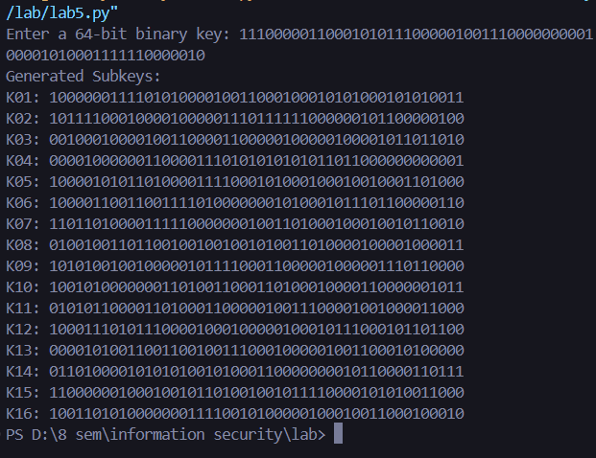
8. Result
The program successfully generated all 16 forty-eight-bit DES subkeys from the 64-bit input key, correctly demonstrating the PC-1, rotation, and PC-2 stages of the DES key schedule.

Lab No: 06 GCD - Euclidean Algorithm
1. Title of Experiment
Program to find the GCD of two integers using the Euclidean algorithm.
2. Objective
To implement a program that computes the Greatest Common Divisor (GCD) of two integers using the Euclidean algorithm.
3. Required Software/Hardware
- A computer running Windows / Linux / macOS
- Visual Studio Code (VS Code) IDE
- Python 3 installed and added to PATH
- An integrated terminal (built into VS Code) to run the program and view its output
4. Theory
The Euclidean Algorithm is a method for finding the Greatest Common Divisor (GCD) of two integers. The GCD is the largest positive integer that divides both numbers without leaving a remainder. The algorithm is based on the principle that the GCD of two numbers also divides their difference.
5. Procedure/Algorithm
- Take two integers as input.
- Ensure the first number is the larger of the two (swap if needed).
- Divide the larger number by the smaller number and note the remainder.
- Replace the larger number with the smaller number, and the smaller number with the remainder.
- Repeat the process until the remainder becomes 0.
- The last non-zero remainder is the GCD; display it.
6. Implementation/Steps
def gcd(a, b):
# Ensure that a is the greater number
if a < b:
a, b = b, a
while b != 0:
remainder = a % b
a = b
b = remainder
return a

# Example usage
first_number = int(input("Enter the first integer: "))
second_number = int(input("Enter the second integer: "))

result = gcd(first_number, second_number)
print(f"The GCD of {first_number} and {second_number} is: {result}")
7. Output/Screenshot
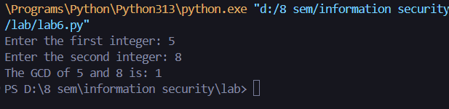

8. Result
The program correctly computed the GCD for multiple pairs of integers using the Euclidean algorithm, and the results matched manual calculation.

Lab No: 07 Multiplicative Inverse (Zn)
1. Title of Experiment
Program to find the multiplicative inverse of a user input integer in Zn.
2. Objective
To implement a program that computes the multiplicative inverse of an integer a modulo n using the Extended Euclidean Algorithm.
3. Required Software/Hardware
- A computer running Windows / Linux / macOS
- Visual Studio Code (VS Code) IDE
- Python 3 installed and added to PATH
- An integrated terminal (built into VS Code) to run the program and view its output
4. Theory
In modular arithmetic, the multiplicative inverse of an integer a modulo n is an integer x such that (a * x) mod n = 1. For the multiplicative inverse to exist, a and n must be coprime, i.e. their greatest common divisor (GCD) must be 1.
To find the multiplicative inverse of a modulo n, we use the Extended Euclidean Algorithm. This algorithm computes the GCD of a and n and also provides coefficients x and y satisfying a*x + n*y = GCD(a, n). If the GCD is 1, then x (mod n) is the multiplicative inverse.
5. Procedure/Algorithm
- Take integer a and modulus n as input.
- Apply the Extended Euclidean Algorithm recursively on n and a to compute gcd(a, n) along with coefficients x and y such that a*x + n*y = gcd(a, n).
- If gcd is not 1, report that the inverse does not exist because a and n are not coprime.
- Otherwise, compute x mod n (adjusted to be positive) as the multiplicative inverse.
- Display the resulting multiplicative inverse (or the error message).
6. Implementation/Steps
def extended_gcd(a, b):
if b == 0:
return a, 1, 0

gcd, x1, y1 = extended_gcd(b, a % b)

x = y1
y = x1 - (a // b) * y1

return gcd, x, y

def multiplicative_inverse(a, n):
gcd, x, y = extended_gcd(a, n)

if gcd != 1:
return f"The multiplicative inverse does not exist as {a} and {n} are not coprime."

# Ensure the result is positive
return (x % n + n) % n

# Example usage
a = int(input("Enter an integer a: "))
n = int(input("Enter the modulus n: "))

inverse = multiplicative_inverse(a, n)

print(f"The multiplicative inverse of {a} modulo {n} is: {inverse}")
7. Output/Screenshot

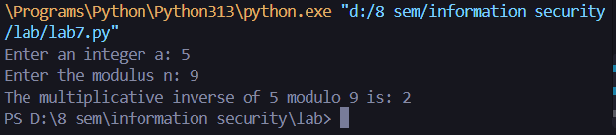
8. Result
The program correctly computed the multiplicative inverse when a and n were coprime, and correctly reported that no inverse exists when they shared a common factor greater than 1.

Lab No: 08 Primality Test – Fermat's Theorem
1. Title of Experiment
Program to test the primality of an integer using Fermat's theorem.
2. Objective
To implement a program that tests whether an integer is prime using Fermat's Little Theorem.
3. Required Software/Hardware
- A computer running Windows / Linux / macOS
- Visual Studio Code (VS Code) IDE
- Python 3 installed and added to PATH
- An integrated terminal (built into VS Code) to run the program and view its output
4. Theory
Fermat's Little Theorem is a fundamental result in number theory that provides a basis for primality testing. According to the theorem, if p is a prime number and a is any integer such that 1 < a < p-1, then a^(p-1) is congruent to 1 (mod p). In other words, if p is prime, raising a to the power of p-1 should give a result congruent to 1 modulo p.
5. Procedure/Algorithm
- Take an integer p to test, and the number of test rounds k.
- If p is less than or equal to 1, it is not prime; if p is 2 or 3, it is prime.
- Otherwise, repeat k times: pick a random base a between 2 and p-2, and compute a^(p-1) mod p using fast modular exponentiation.
- If the result is not equal to 1 for any chosen base, declare p as composite.
- If all k tests pass, declare p as 'likely prime'.
6. Implementation/Steps
import random

# Function to compute power with modulo
def mod_exp(base, exp, mod):
result = 1
base = base % mod

while exp > 0:
if exp % 2 == 1:
result = (result * base) % mod
exp = exp >> 1 # Divide the exponent by 2
base = (base * base) % mod

return result

# Function to test primality using Fermat's Little Theorem
def is_prime(p, k):
if p <= 1:
return False # Numbers <= 1 are not prime
if p <= 3:
return True # 2 and 3 are prime numbers

# Test k different values of a
for _ in range(k):
a = random.randint(2, p - 2) # Random base a between 2 and p-2
if mod_exp(a, p - 1, p) != 1:
return False

return True

# Example usage
p = int(input("Enter an integer to test for primality: "))

# Number of bases to test
k = 5 # The more tests, the more accurate the result

if is_prime(p, k):
print(f"{p} is likely a prime number.")
else:
print(f"{p} is not a prime number.")
7. Output/Screenshot

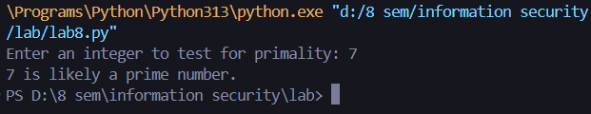
8. Result
The program correctly classified prime and composite numbers using Fermat's Little Theorem across multiple test cases.

Lab No: 09 Primality Test - Miller-Rabin
1. Title of Experiment
Program to test the primality of an integer using the Miller-Rabin algorithm.
2. Objective
To implement a program that tests whether an integer is prime using the Miller-Rabin probabilistic primality test.
3. Required Software/Hardware
- A computer running Windows / Linux / macOS
- Visual Studio Code (VS Code) IDE
- Python 3 installed and added to PATH
- An integrated terminal (built into VS Code) to run the program and view its output
4. Theory
The Miller-Rabin Primality Test is a probabilistic algorithm used to determine if a number is prime. It is more robust and reliable than Fermat's test because it reduces the chances of false positives (identifying composite numbers as prime).
The test works by repeatedly testing a number against randomly chosen bases and analyzing the properties of those bases under modular exponentiation. If the number passes all tests, it is likely prime; if it fails any test, it is definitely composite.
5. Procedure/Algorithm
- Take an integer n to test and the number of rounds k.
- Handle the base cases (n <= 1, n <= 3, even n).
- Write n-1 as 2^s times d, where d is odd.
- Repeat k times: choose a random base a, and compute x = a^d mod n.
- If x is 1 or n-1, the test passes for this round; otherwise repeatedly square x up to s-1 times, checking whether it becomes n-1.
- If none of the checks succeed for some round, declare n composite; otherwise, after all k rounds pass, declare n 'likely prime'.
6. Implementation/Steps
import random
# Function to compute power with modulo (modular exponentiation)
def mod_exp(base, exp, mod):
result = 1
base = base % mod
while exp > 0:
if exp % 2 == 1:
result = (result * base) % mod
exp = exp >> 1 # Divide the exponent by 2
base = (base * base) % mod
return result

# Miller-Rabin Primality Test
def is_prime(n, k):
if n <= 1:
return False # Numbers <= 1 are not prime
if n <= 3:
return True # 2 and 3 are prime numbers
if n % 2 == 0:
return False # Even numbers > 2 are not prime

# Find d such that n-1 = 2^s * d with d odd
d = n - 1
s = 0
while d % 2 == 0:
d >>= 1 # Divide d by 2
s += 1
for _ in range(k):
a = random.randint(2, n - 2) # Random base a between 2 and n-2
x = mod_exp(a, d, n)
if x == 1 or x == n - 1:
continue
is_composite = True
for _ in range(1, s):
x = mod_exp(x, 2, n)
if x == 1:
return False # n is composite
if x == n - 1:
is_composite = False
break
if is_composite:
return False # n is composite
return True # n is likely prime
# Example usage
n = int(input("Enter an integer to test for primality: "))

# Number of bases to test
k = 5 # The more tests, the more accurate the result

if is_prime(n, k):
print(f"{n} is likely a prime number.")
else:
print(f"{n} is not a prime number.")
7. Output/Screenshot
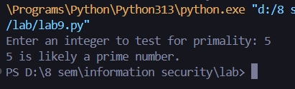
8. Result
The program correctly classified prime and composite numbers using the Miller-Rabin test, demonstrating improved reliability compared to Fermat's test.

Lab No: 10 Euler's Totient Function
1. Title of Experiment
Program to find the Euler totient function of a user input integer.
2. Objective
To implement a program that computes Euler's Totient function (phi(n)) for a user input integer.
3. Required Software/Hardware
- A computer running Windows / Linux / macOS
- Visual Studio Code (VS Code) IDE
- Python 3 installed and added to PATH
- An integrated terminal (built into VS Code) to run the program and view its output
4. Theory
Euler's Totient Function, denoted as phi(n), counts the number of positive integers up to n that are relatively prime to n (i.e. their GCD with n is 1).
The totient function is important in number theory, particularly in Euler's theorem, which generalises Fermat's Little Theorem: if n is a positive integer and a is an integer with gcd(a, n) = 1, then a^phi(n) is congruent to 1 (mod n).
5. Procedure/Algorithm
- Take an integer n as input.
- If n is 1, the totient is 1.
- Otherwise, find the prime factors of n by trial division up to the square root of n; for each prime factor p found, divide it out of n completely and multiply the running result by (1 - 1/p).
- If a remaining factor greater than 1 exists after the loop, it is also a prime factor -- apply the same adjustment to the result.
- Display the resulting Euler's Totient value.
6. Implementation/Steps
def euler_totient(n):
if n == 1:
return 1

result = n
i = 2
while i * i <= n:
if n % i == 0:
while n % i == 0:
n //= i
result -= result // i
i += 1
if n > 1:
result -= result // n

return result

# Example usage
n = int(input("Enter an integer to find its Euler's Totient Function: "))

print(f"Euler's Totient Function of {n} is: {euler_totient(n)}")
7. Output/Screenshot
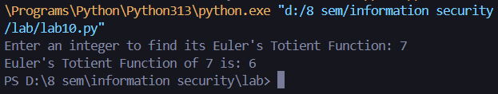
8. Result
The program correctly computed Euler's Totient function for multiple input integers, and the results matched manual calculation.

Lab No: 11 Diffie-Hellman Key Exchange
1. Title of Experiment
Program to simulate key exchange using the Diffie-Hellman key exchange algorithm.
2. Objective
To implement a program that simulates two parties (Alice and Bob) establishing a shared secret key using the Diffie-Hellman key exchange algorithm.
3. Required Software/Hardware
- A computer running Windows / Linux / macOS
- Visual Studio Code (VS Code) IDE
- Python 3 installed and added to PATH
- An integrated terminal (built into VS Code) to run the program and view its output
4. Theory
The Diffie-Hellman key exchange algorithm is a method used to securely exchange cryptographic keys over a public channel. It allows two parties to generate a shared secret key, used for later encryption/decryption, without ever transmitting the key itself. It is based on the difficulty of computing discrete logarithms in a finite field.
5. Procedure/Algorithm
- Agree on public parameters: a prime number p and a generator g, both publicly known.
- Alice chooses a private key a and computes her public key A = g^a mod p.
- Bob chooses a private key b and computes his public key B = g^b mod p.
- Alice and Bob exchange their public keys A and B over the public channel.
- Alice computes the shared secret as B^a mod p; Bob computes it as A^b mod p.
- Verify both computed shared secrets are equal -- this value becomes the shared secret key.
6. Implementation/Steps
def mod_exp(base, exp, mod):
result = 1
while exp > 0:
if exp % 2 == 1:
result = (result * base) % mod
exp = exp >> 1
base = (base * base) % mod
return result

# Generate a large prime number (p) and a primitive root (g) for the demonstration
p = 23 # In real applications, use much larger prime numbers
g = 5 # In real applications, select a generator carefully

print(f"Public parameters: p = {p}, g = {g}")

# Alice's private key (a) and public key (A)
a = 6 # Alice's private key
A = mod_exp(g, a, p) # Alice's public key
print(f"Alice's private key: a = {a}")
print(f"Alice's public key: A = {A}")

# Bob's private key (b) and public key (B)
b = 15 # Bob's private key
B = mod_exp(g, b, p) # Bob's public key
print(f"Bob's private key: b = {b}")
print(f"Bob's public key: B = {B}")

# Exchange public keys and compute the shared secret
# Alice computes the shared secret s using Bob's public key B and her private key a
shared_secret_alice = mod_exp(B, a, p)
print(f"Shared secret computed by Alice: {shared_secret_alice}")
# Bob computes the shared secret s using Alice's public key A and his private key b
shared_secret_bob = mod_exp(A, b, p)
print(f"Shared secret computed by Bob: {shared_secret_bob}")
# Both should be the same
if shared_secret_alice == shared_secret_bob:
print(f"Key exchange successful. Shared secret: {shared_secret_alice}")
else:
print("Key exchange failed. Secrets do not match.")
7. Output/Screenshot
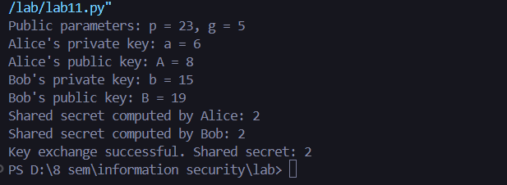
8. Result
Both Alice and Bob computed the same shared secret key independently, confirming that the Diffie-Hellman key exchange completed successfully.

Lab No: 12 Primitive Root Test
1. Title of Experiment
Program to test whether a user input integer g is a primitive root of a prime number p.
2. Objective
To implement a program that checks whether a given integer g is a primitive root of a given prime number p.
3. Required Software/Hardware
- A computer running Windows / Linux / macOS
- Visual Studio Code (VS Code) IDE
- Python 3 installed and added to PATH
- An integrated terminal (built into VS Code) to run the program and view its output
4. Theory
A primitive root of a prime number p is an integer g such that the powers of g modulo p generate all integers from 1 to p-1. In other words, g is a primitive root modulo p if the set {g^1 mod p, g^2 mod p, ..., g^(p-1) mod p} equals the set {1, 2, ..., p-1}.
5. Procedure/Algorithm
- Take a prime number p and a candidate integer g as input.
- Check that g is a positive integer smaller than p.
- Compute g^i mod p for i = 1 to p-1, storing every result seen so far.
- If any repeated value appears before all p-1 values are produced, g is not a primitive root.
- If every value from 1 to p-1 is produced exactly once, g is a primitive root of p.
6. Implementation/Steps
def mod_exp(base, exp, mod):
result = 1
while exp > 0:
if exp % 2 == 1:
result = (result * base) % mod
exp = exp >> 1
base = (base * base) % mod
return result

def is_primitive_root(g, p):
# Check if g is a valid candidate
if g <= 0 or g >= p:
return False

seen = []

# Check the powers of g modulo p
for i in range(1, p):
value = mod_exp(g, i, p)
if value in seen:
return False
seen.append(value)

# If all values from 1 to p-1 are seen, g is a primitive root
seen.sort()
for i in range(1, p):
if seen[i - 1] != i:
return False

return True

# Example usage
p = int(input("Enter a prime number (p): "))
g = int(input(f"Enter a number (g) to check if it's a primitive root of {p}: "))

# Validate input
if p <= 1 or g <= 0:
print("Invalid input. Both inputs must be positive integers, and p must be greater than 1.")
else:
if is_primitive_root(g, p):
print(f"{g} is a primitive root of {p}.")
else:
print(f"{g} is not a primitive root of {p}.")
7. Output/Screenshot
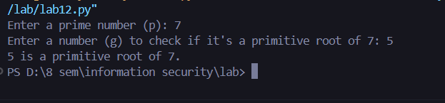
8. Result
The program correctly identified whether a given integer was a primitive root of a prime number, verified against known primitive roots (e.g. 3 is a primitive root of 7).

Lab No: 13 Simulating Malicious Logic
1. Title of Experiment
Program to simulate malicious logic.
2. Objective
To implement a program that simulates a simple example of malicious logic -- unauthorized modification of a local file -- for educational understanding of malware behaviour.
3. Required Software/Hardware
- A computer running Windows / Linux / macOS
- Visual Studio Code (VS Code) IDE
- Python 3 installed and added to PATH
- An integrated terminal (built into VS Code) to run the program and view its output
- Write permission in the working folder (the script creates/modifies a local text file)
4. Theory
Malicious logic includes any code or software designed to harm, disrupt, or gain unauthorised access to computer systems. This can include viruses, worms, Trojan horses, and other malware. Understanding how malicious logic works helps in developing better security practices and defenses.
5. Procedure/Algorithm
- Define a filename representing a 'sensitive' data file.
- If the file does not already exist, create it with some initial content.
- Read and display the file's original content.
- Append additional content to the file without requesting authorization, simulating a malicious modification.
- Read and display the file's modified content to show the unauthorized change.
6. Implementation/Steps
import os

# Simulate Malicious Logic: Unauthorized File Modification
def simulate_malicious_logic():
filename = "sensitive_data.txt"

# Check if the file exists
if not os.path.exists(filename):
# Create the file if it does not exist
with open(filename, "w") as f:
f.write("This is some sensitive data.\n")

# Display original content
print("Original Content:")
with open(filename, "r") as f:
print(f.read())

# Maliciously modify the file
with open(filename, "a") as f:
f.write("This data has been maliciously modified!\n")

# Display modified content
print("\nModified Content:")
with open(filename, "r") as f:
print(f.read())

# Run the simulation
simulate_malicious_logic()
7. Output/Screenshot
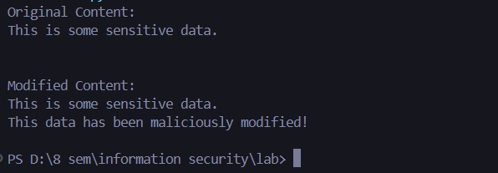
8. Result
The simulation successfully demonstrated how a program could silently modify a "sensitive" file without authorization, illustrating a simple example of malicious logic and why file-integrity monitoring matters.

Lab No: 14 Birthday Paradox Problem
1. Title of Experiment
Program to demonstrate the Birthday Paradox Problem.
2. Objective
To compute and demonstrate, using Python, the probability that at least two people in a group share the same birthday as group size increases (the Birthday Paradox).
3. Required Software/Hardware
- A computer running Windows / Linux / macOS
- Visual Studio Code (VS Code) IDE
- Python 3 installed and added to PATH
- An integrated terminal (built into VS Code) to run the program and view its output
- Microsoft Excel or Google Sheets (to plot the probability chart from the printed table)
4. Theory
The Birthday Paradox Problem, also known as the Birthday Problem, is a probability puzzle that demonstrates a counterintuitive phenomenon: in a random group of just 23 people, there is approximately a 50% chance that at least two individuals share the same birthday.
For example: with 23 people in a room, the probability that at least two share a birthday is over 50%. Despite seeming unlikely, this is a mathematical reality arising from how probabilities combine across many pairs of people in a group.
5. Procedure/Algorithm
- For each group size n from 1 to 27, compute the probability that no two people share a birthday, assuming 365 equally likely birthdays.
- Compute the probability that at least two people share a birthday as 1 minus the probability of no match.
- Convert this probability to a percentage.
- Tabulate the results for n = 1 to 27.
- Plot the percentage of matching birthdays against the number of people to visualize the point where it crosses 50%.
6. Implementation/Steps
def probability_no_match(n, days=365):
prob = 1.0
for i in range(n):
prob *= (days - i) / days
return prob

print(f"{'No. of people':<15}{'Prob not matching':<20}{'Prob matching':<18}{'Percentage (%)'}")
for people in range(1, 28):
p_no_match = probability_no_match(people)
p_match = 1 - p_no_match
print(f"{people:<15}{p_no_match:<20.10f}{p_match:<18.10f}{p_match * 100:.4f}")
7. Output/Screenshot
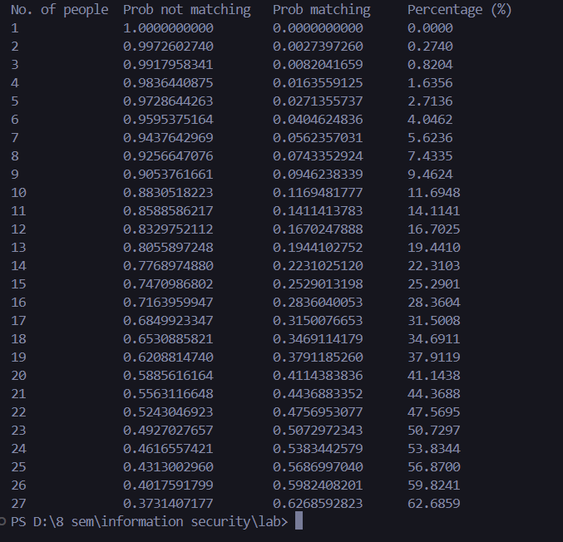
8. Result
The computed data confirmed the Birthday Paradox: the probability of a shared birthday crosses 50% once the group size reaches 23, and continues rising steeply afterwards, reaching about 63% at 27 people.

